1. Different Maven commands to run test cases

mvn test --> edi estea una test cases ani run aavutai and .class files create aavutai target folder lo.

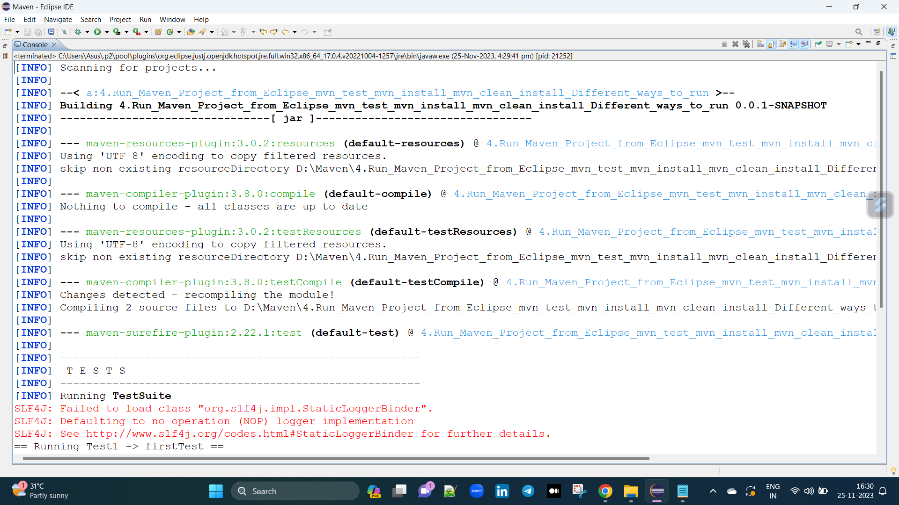

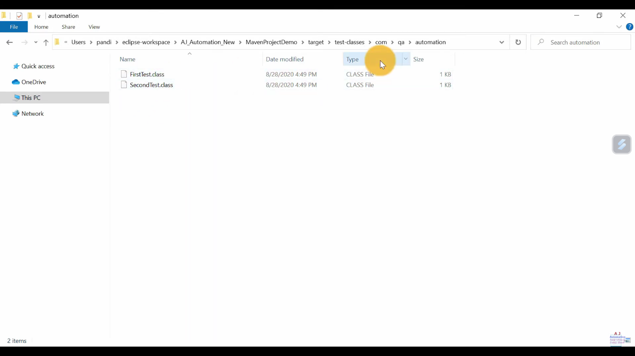

mvn install --> edi estea test cases ani run aavutai and vaka jar file create iedi target folder lo.

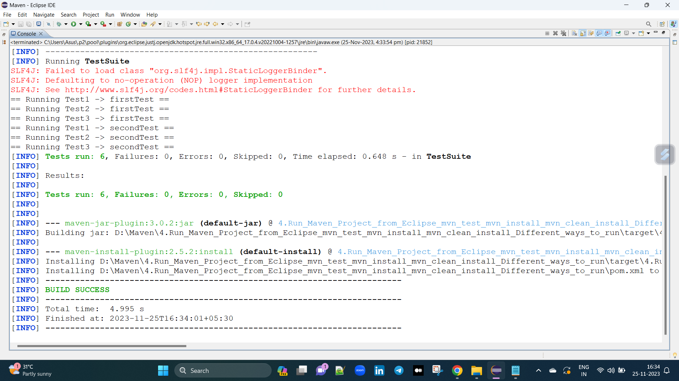

mvn clean --> edi estea old reports or etc which is in target folder are deleted.

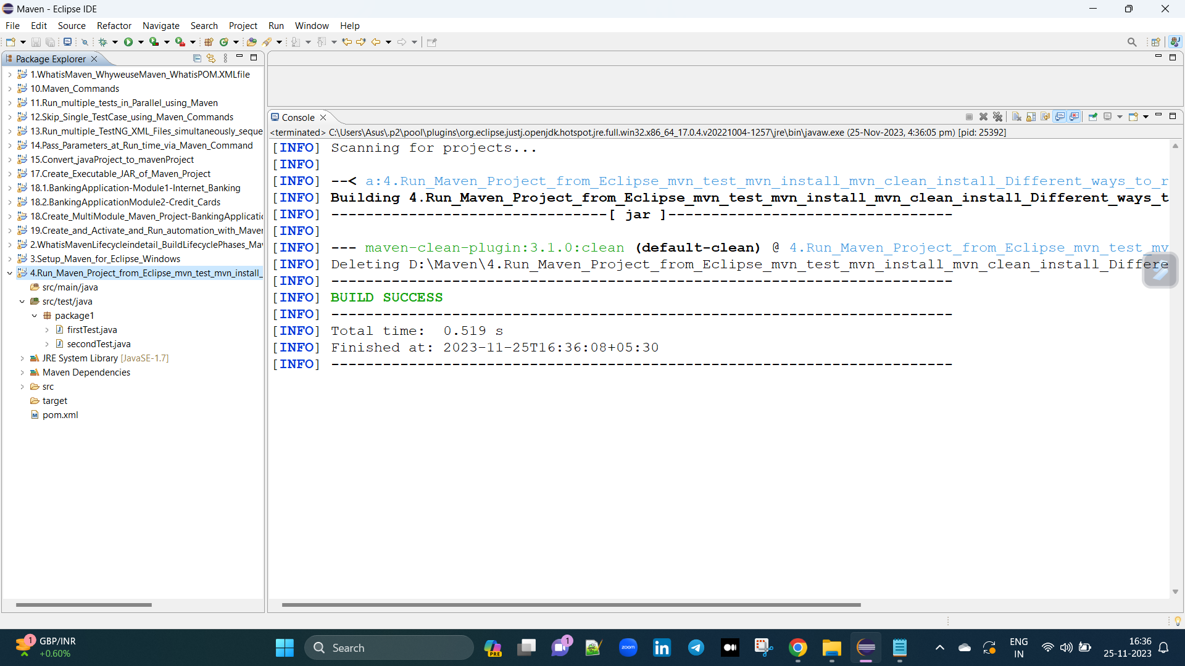

mvn clean install --> edi estea old reports or etc which is in target folder are deleted and run aavutai and vaka jar file create iedi target folder lo.

2. Run Maven project from Eclipse in multiple ways

one way : manm project pai right click echi -> run as -> mvn test (or) mvn install (or) mvn clean deani pai ana manam click chaivachu.

second way : manm package pai right click echi -> run as -> mvn test (or) mvn install (or) mvn clean deani pai ana manam click chaivachu.

third way : manm pom.xml pai right click echi -> run as -> mvn test (or) mvn install (or) mvn clean deani pai ana manam click chaivachu.

fourth way : manm project pai right click echi -> run as -> maven build loki velli -> test (or) install (or) clean deani pai ana manam click chaivachu.

fifth way : manm package pai right click echi -> run as -> maven build loki velli -> test (or) install (or) clean deani pai ana manam click chaivachu.

sixth way : manm pom.xml pai right click echi -> run as -> maven build loki velli -> test (or) install (or) clean deani pai ana manam click chaivachu.

3. Add the plugins in pom.xml=

Where and how to add Compiler Plugin , surefire Plugin

Plugin ala use aavutai antea

compile cheaseatapudu compiler plugin use chestamu

test cheaseatapudu surefire plugin use chestamu

packaging cheaseatapudu jar plugin use chestamu

install cheaseatapudu install plugin use chestamu

clean cheaseatapudu clean plugin use chestamu

validate cheaseatapudu resourse plugin use chestamu